## **...Open your eyes...**

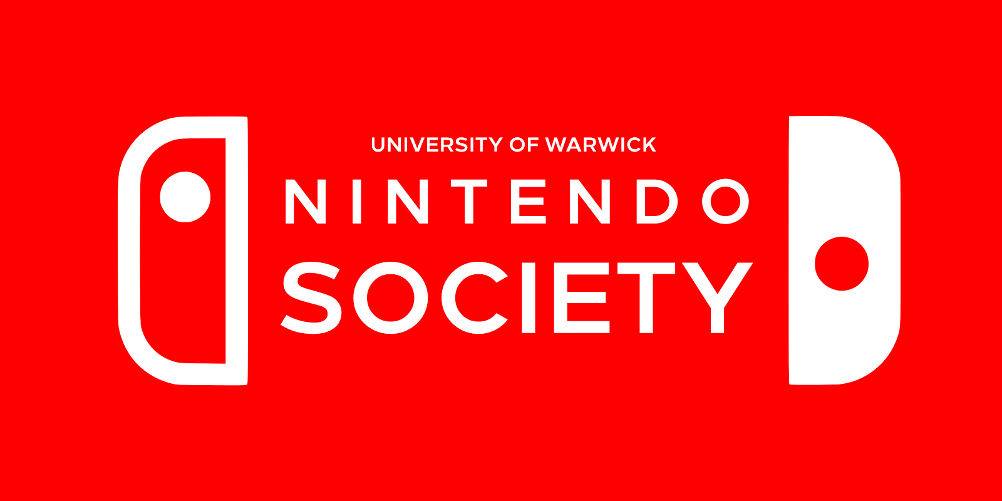

## **...It's Nintendo Society News Time… with New Branding! :O**

Merry Switchmas to you all! Welcome to the third email, and we have Switched to our new branding! It seemed like a sensible time to rebrand so here it is, and it has been applied to all our social media (links at the end of the email) so I hope everyone likes it! :)

And with that, here are this week's announcements:

### **TEDx Warwick**

### **Saturday 4/3, Warwick Arts Centre, 10am-6pm**

We have been invited to be one of the entertainment stalls during this year’s TEDx event, and will have consoles playable in the Arts Centre and flyers to be distributed! An exciting opportunity for us, so come support or visit us during the day. We will also have Nintendo Switch playable at the event so do check us out.

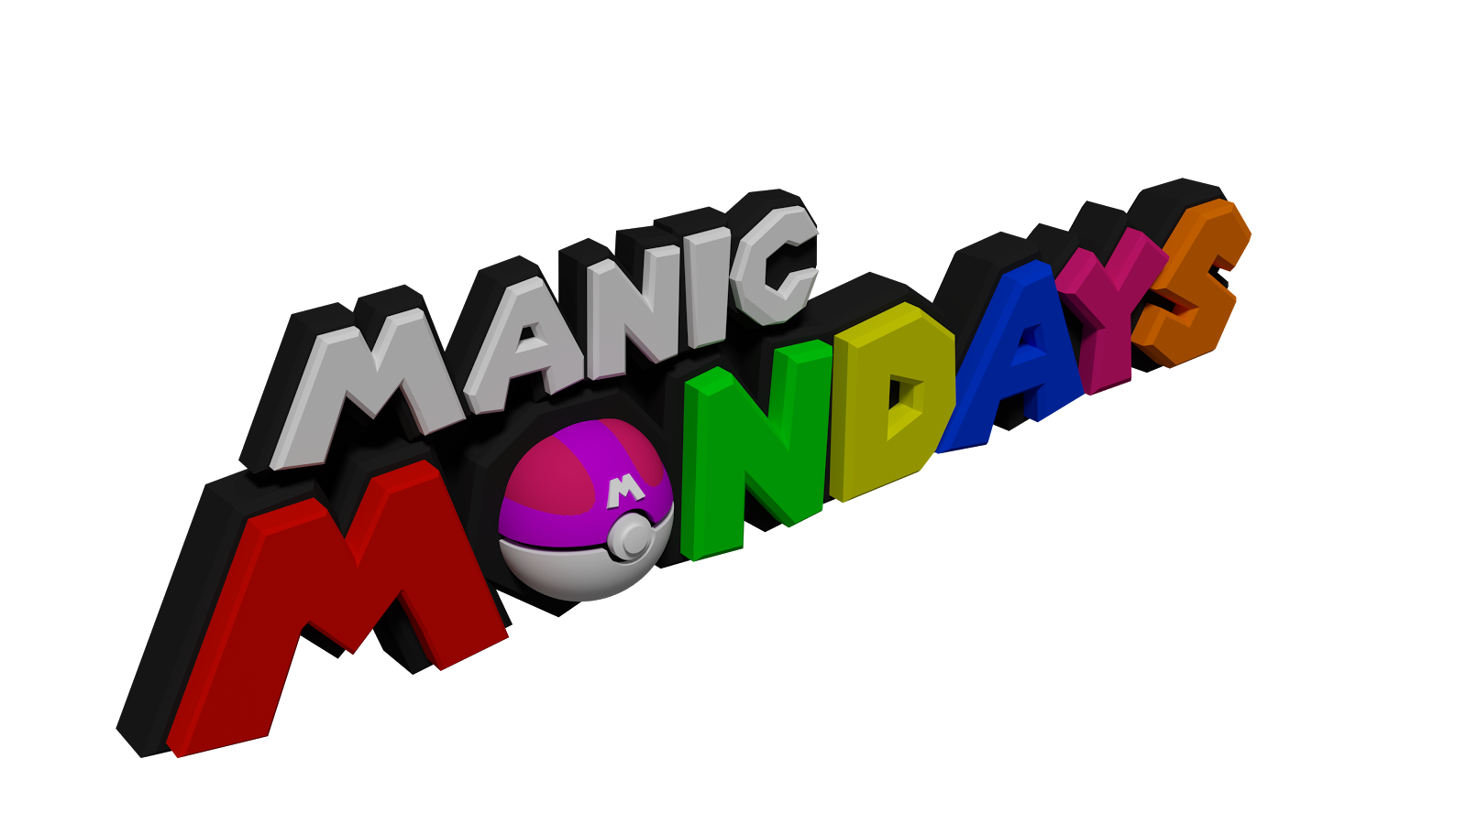

### **Manic Mondays (Switch-mas Day)**

### **Monday 6/3, R0.03/4, 6-10pm**

Nintendo Switch will be playable on Monday! There will be ~3 Switch consoles with a selection of The Legend of Zelda: Breath of the Wild, 1 2 Switch, Snipperclips and Fast RMX playable. Be some of the first to experience the Nintendo Switch days after release! :D

We will also have Wii U consoles ready, including another attempt at lifting the Strikers Cup in Mario Strikers!



### **Smash Wednesday**

### **Wednesday 8/3, OC0.04, 3-10pm**

Our weekly Smash event returns! Smash 64, Melee, Brawl and Wii U will be part of a 5 game crew battle this week. Go to our Facebook page to vote for the 5th game, and also for our team captains who will choose the crews! ***NOTE the time change!***

---------------------------------------------------------------------------------------

Well then, folks, until next time, staaaay fresh!

And Happy Gaming! :D

Timothy Sit

Nintendo Society Incoming President

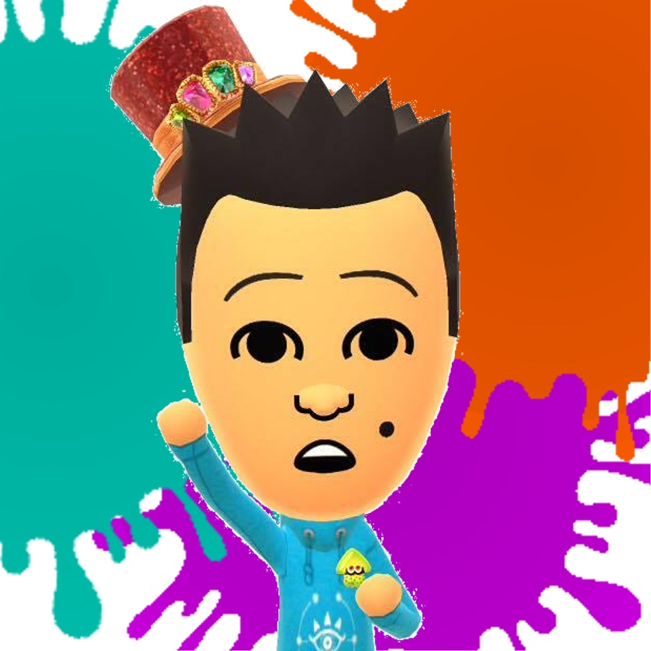

---------------------------------------------------------------------------------------

### **Find us on Social Media:**

Join our Facebook group:<https://www.facebook.com/groups/warwicknintendo/>

Follow our Twitter:<https://twitter.com/warwicknintendo>

Join our Discord Chat:<https://discordapp.com/invite/Rf6QyfG>

Subscribe to our YouTube:<https://www.youtube.com/channel/UCzO_bZNfQDCAQa_zkEUgGVg>